CMPS 350- Web Development Fundamentals

**Assignment 3**

|  |  |
| --- | --- |
| **Student Name** | Syed Ahmad Faraz Subzwari |
| **Student Id** | SS202105006 |
| **Email** | Ss2105006@qu.edu.qa |

**Grading Rubric - - In the *Functionality* column please specify either: *Working (completed x%)*, *Not Working (completed x%)* or *Not done*.**

|  |  |  |  |  |
| --- | --- | --- | --- | --- |
| Criteria | % | Functionality* | Quality of the implementation (Instructor Feedback) | Score |
| List Book | 25 | ***Working (completed 100%)*** |  | 25 |
| Add Book | 20 | ***Working (completed 100%)*** |  | 20 |
| Update Book | 25 | ***Working (completed 100%) Working (completed 100%)***  ***Just the display doesn’t work but it saved so it is 20/25*** |  | 20 |
| Search Book | 20 | ***Working (completed 100%)*** |  | 20 |
| Delete Book | 10 | ***Working (completed 100%)*** |  | 10 |
| Did Not Submit the testing sheet | -10 | N/A |  |  |
| Total | 100 | 95 |  | 95 |
| Copying and/or plagiarism or not being able to explain or answer questions about the implementation | -100 |  |  |  |

**Possible grading for functionality**:

* ***Complete and Working*** (get 70% of the assigned grade),
* ***Complete and Not working*** (lose 60% of assigned grade)
* ***Not done*** get 0.
* The remaining grade is assigned to the quality of the implementation. Quality includes meaningful naming of identifiers, no redundant code, simple and efficient design, clean code without unnecessary files/code, use of comments where necessary, proper white space and indentation. **Marks will be reduced** forcode duplication, poor/inefficient coding practices, poor naming of identifiers and unnecessary complex/poor user interface design.
* Must submit screenshots in this **Testing-GradingSheet.docx** (otherwise - 10pts).

## Testing evidence

Add the screenshots of your work

**List Book:**

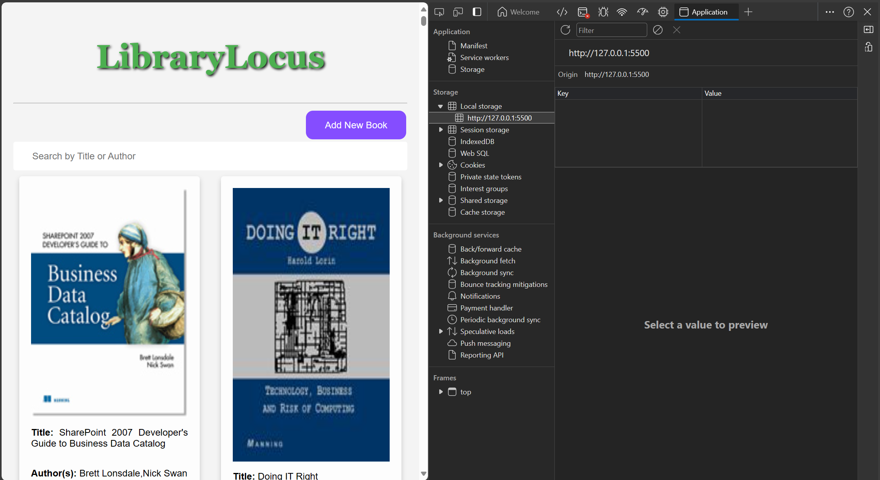

In the image above we can see that I have deleted the Local Storage so that my Program is forced to fetch from the API rather than relying on the saved books in the Local Storage.

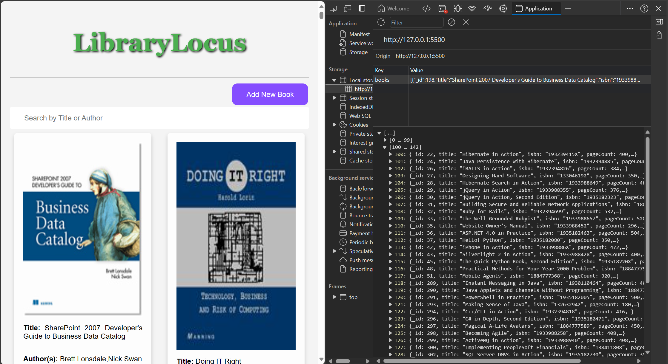

Now, in the image above we can see that upon reloading the webpage, my website has fetched the results from the API and stored them for use in the future.

**Add Book:**

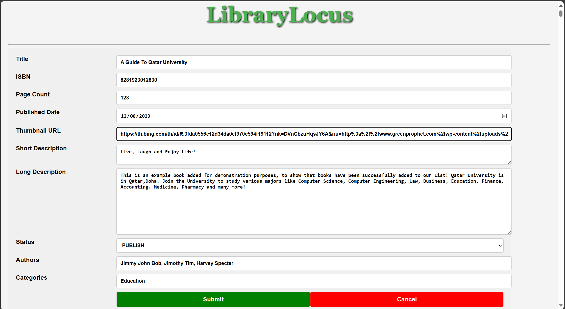

Upon clicking the purple add book button, an empty form is generated. In the image above I have filled out this form to create a sample book. Let us observe that this book is added in the next screenshot.

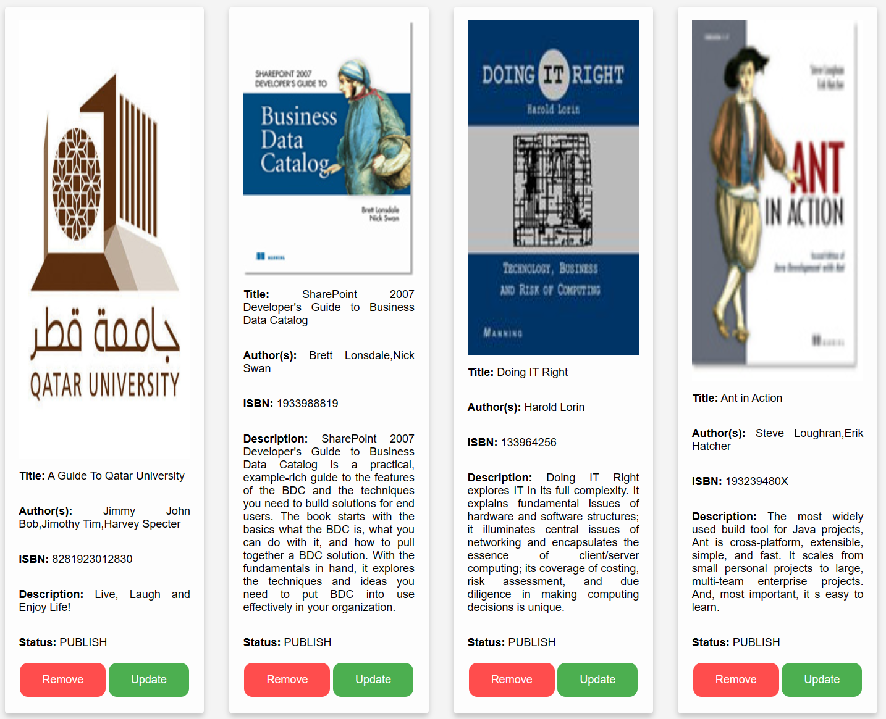

We can see that the new book is added on the left side of the page, and the information is the same as the form that I showed in the previous image.

**CONTINUED ON NEXT PAGE**

**Update Book:**

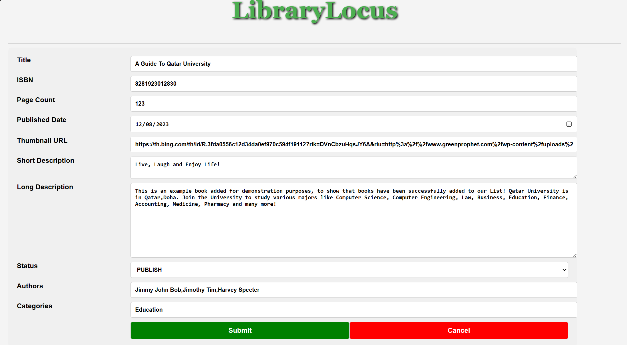

Suppose that I want to update the book. When I click the update button of the Qatar University book, this form reopens and automatically fills out the information.

Now let’s say I want to change the status of the book to Draft, and the title to The Qatar University Experience, and I want to put the author as Bob Ross.

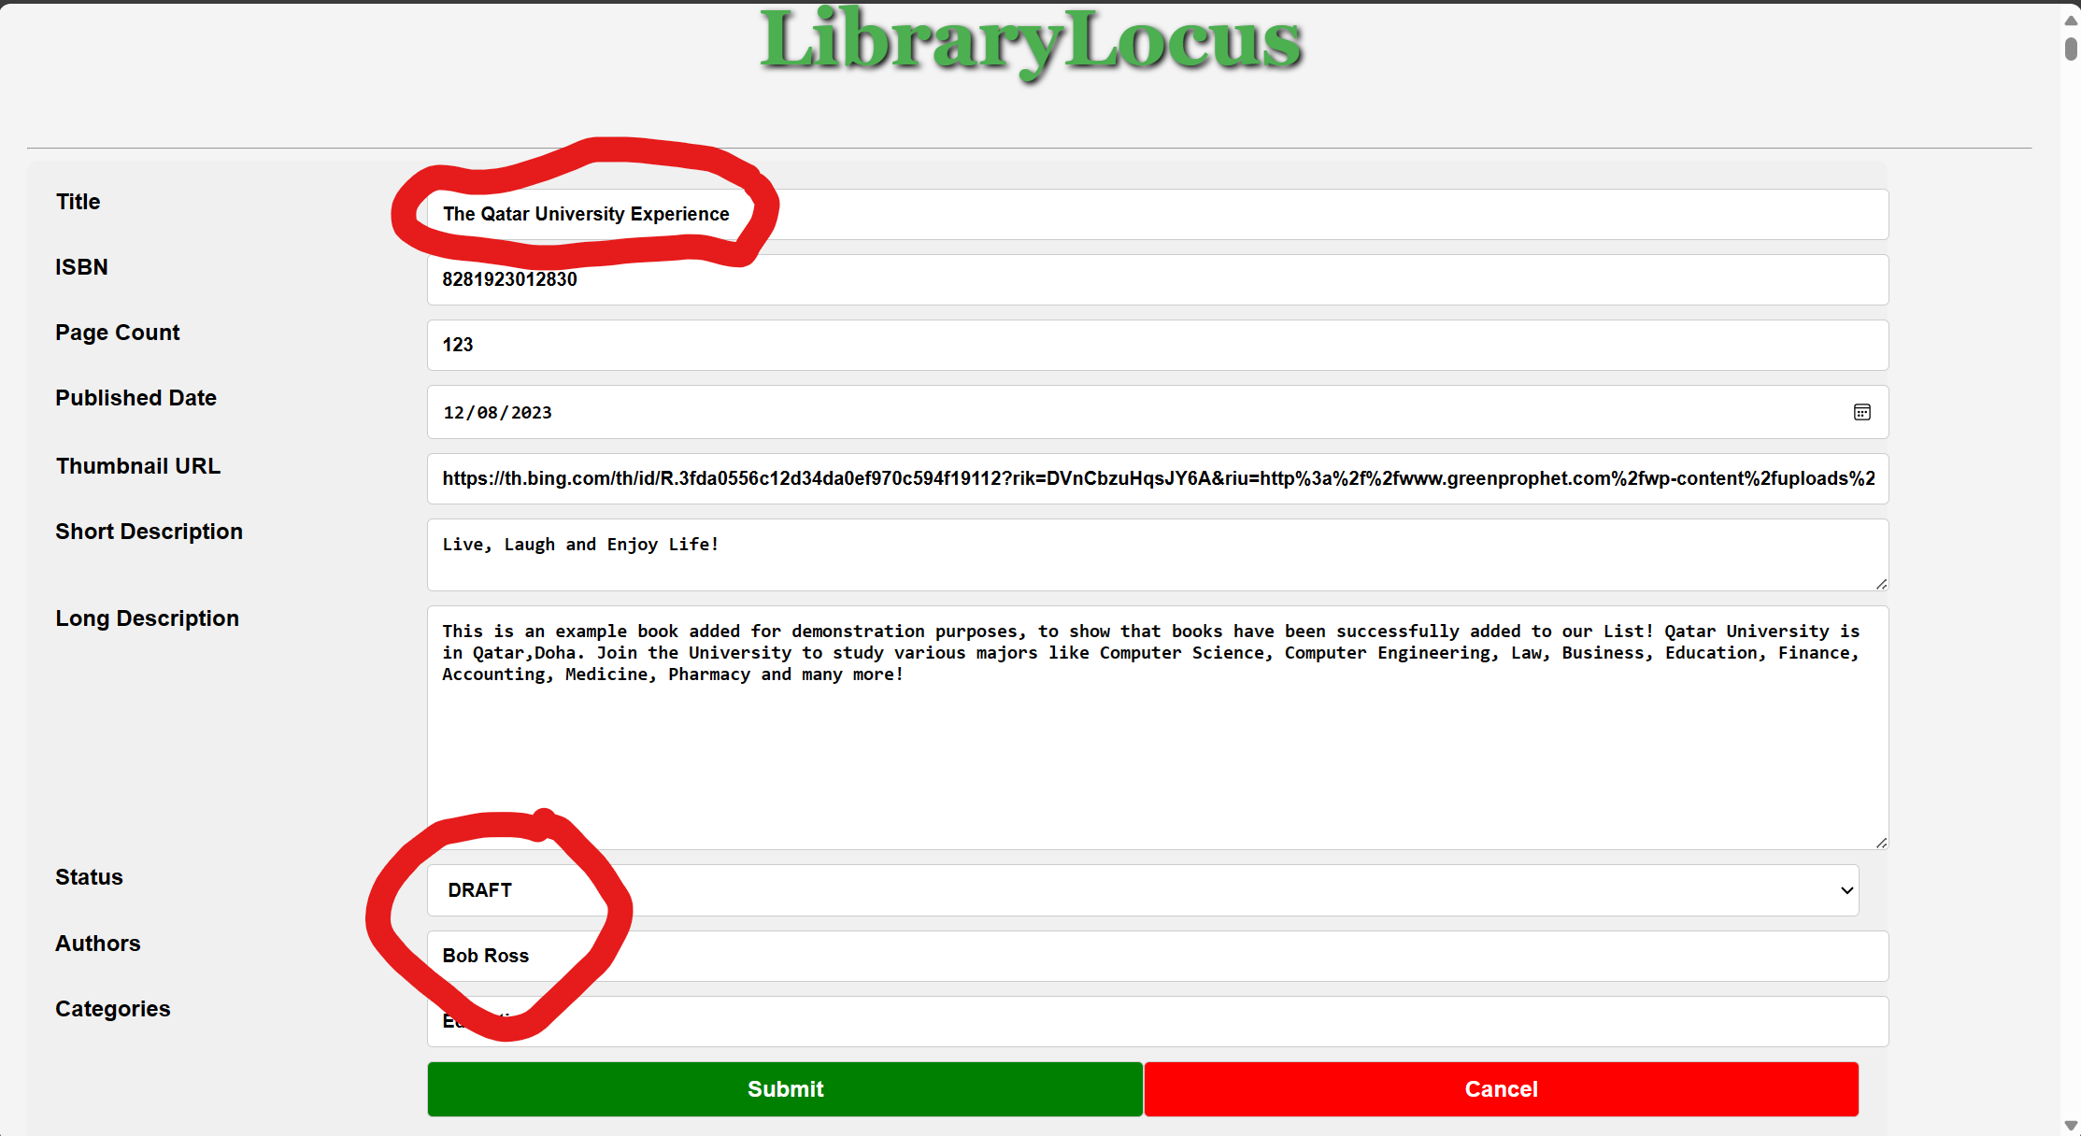

As we can see in the image above I have typed those changes and in the next image we can see the Card has indeed been changed.  
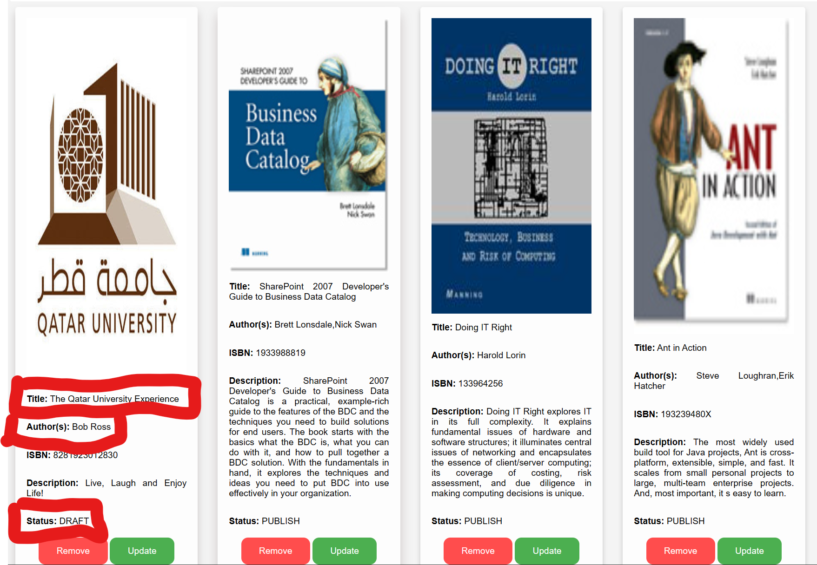

The book has been properly updated.

**Search Book:**

**­**Lets say that I want to search all books that have “Jer” in the title or as one of the authors (As requested in the Demo Video.)

We can see that only books that have “Jer” in the title or authors are returned.

In this example only the Authors have “Jer” (Jeremy, Jerome).

Next Lets see and example that have “Share” in the title or in the authors names.

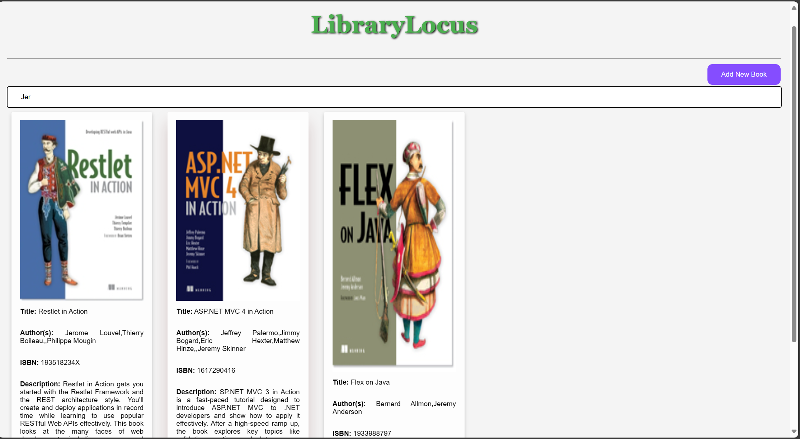

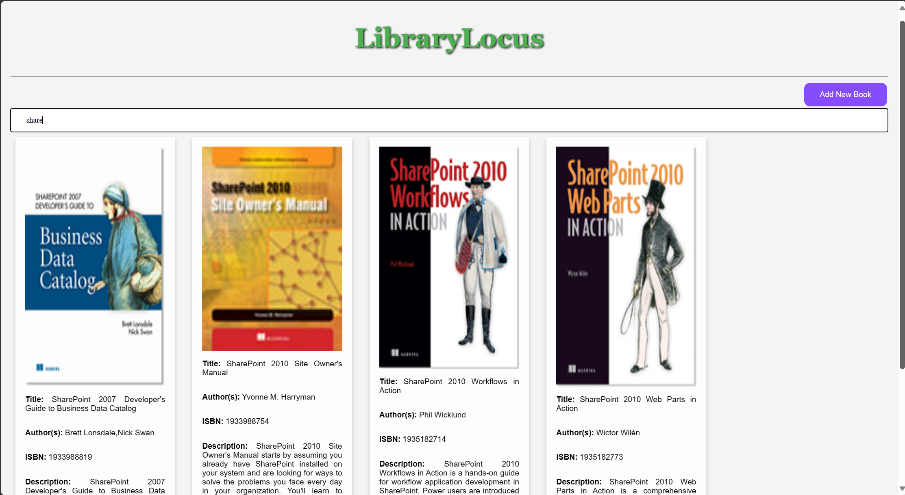

We can see that only the books which have Share in the title or in the names of the authors, are selected. (Of course, no author has a name share so only the titles of the books are returned.)

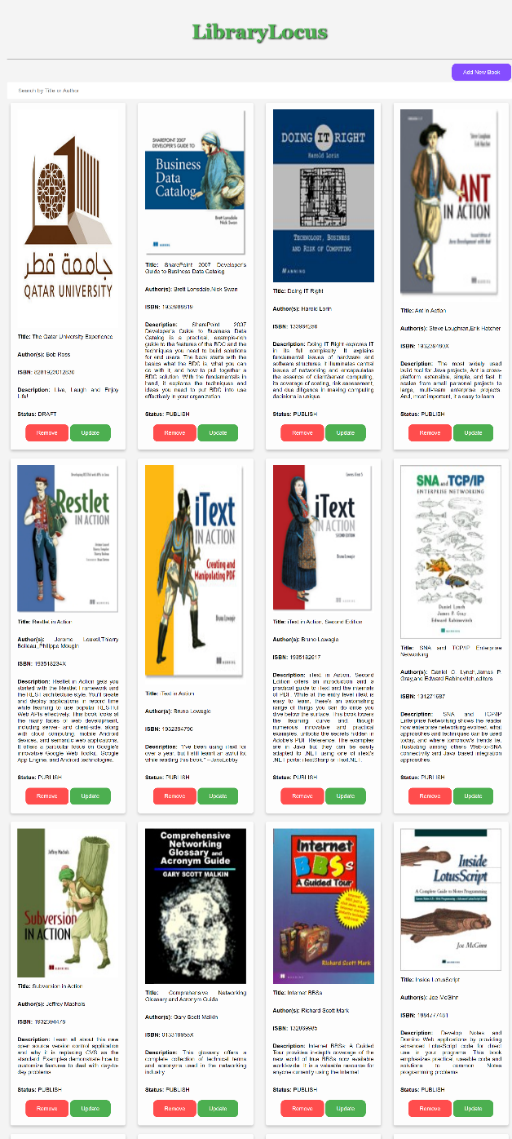**Delete Book:**

Suppose that I want to remove some books, let us see the expected and observed behaviors.

If I am to delete Business Data Catalog (2nd book from left on first row), I would expect the book to be removed. Additionally, I would expect “Doing IT right” (on the right of the previously mentioned book) to take its place.

All Books should be shifted one place.

We can observe the Real Behavior in the next page:

**CONTINUED ON NEXT PAGE**

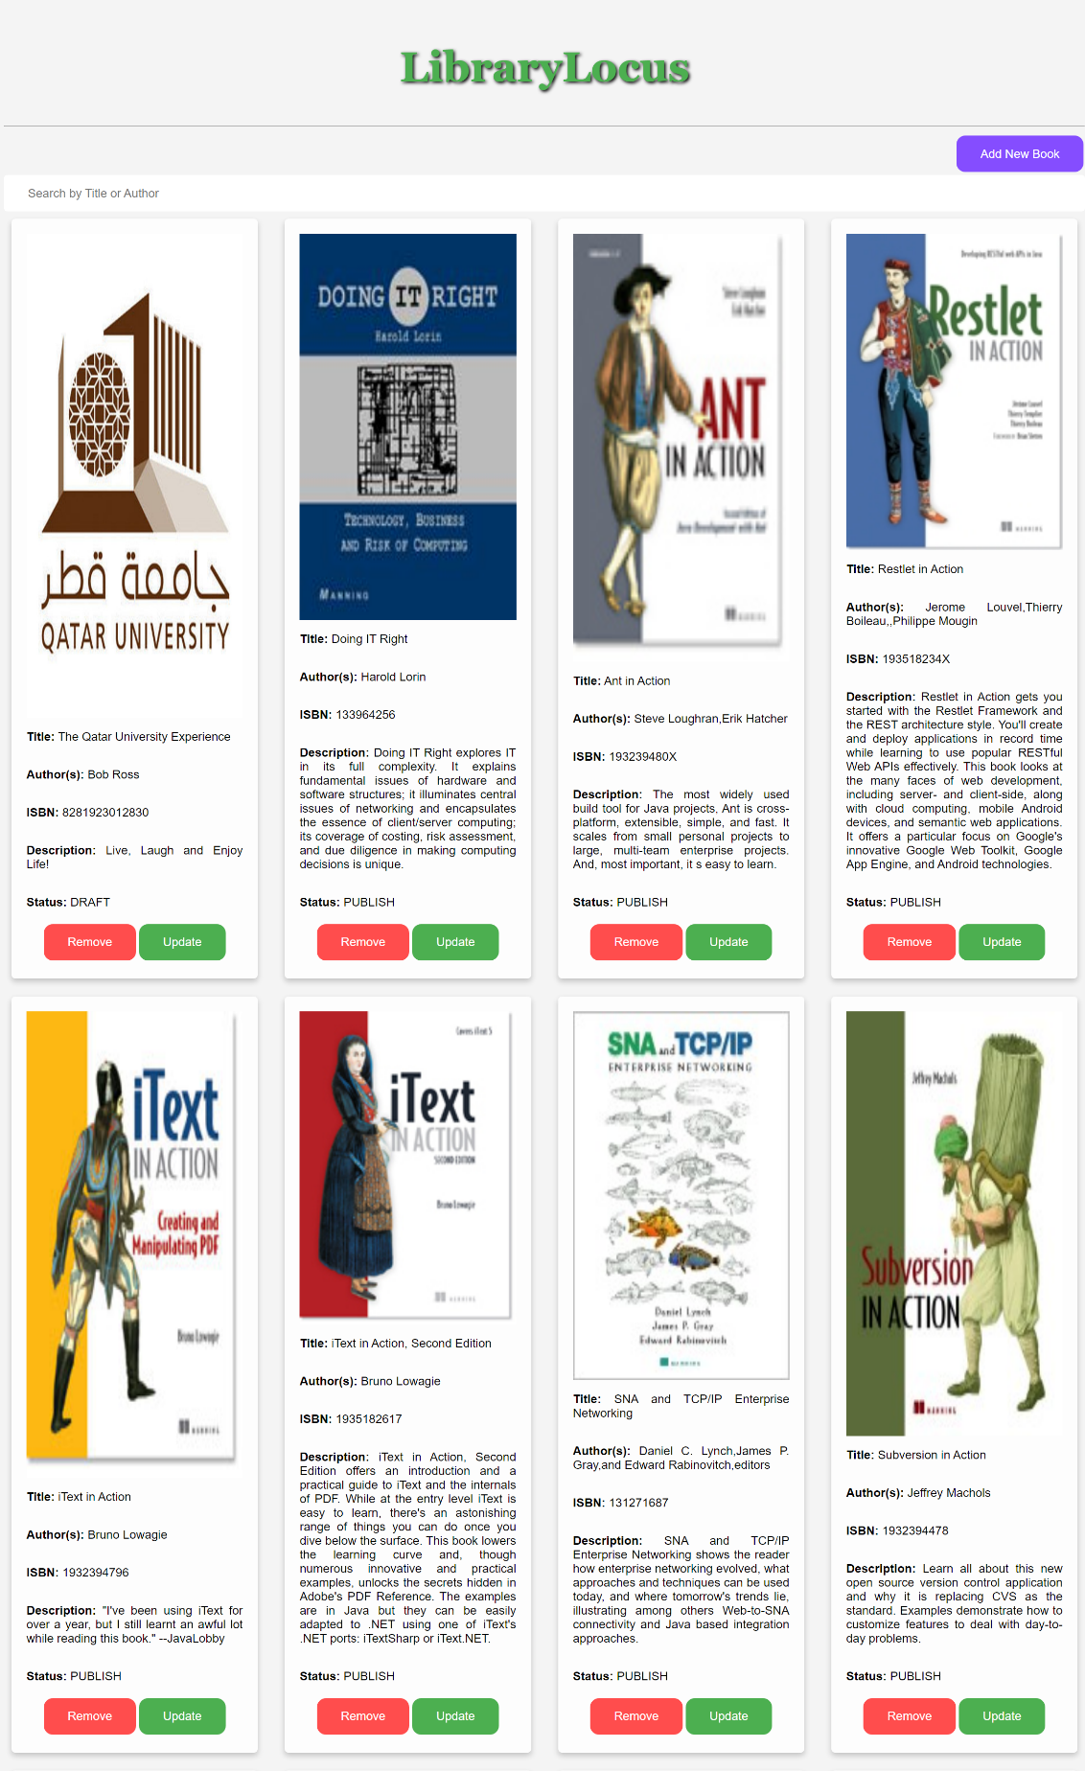As Expected, the Books are shifted by one place to replace the removed book!